Web Design and Development

4COSC011W

Report

Author: Anuda Bogahawattage

Student ID: 2022030

UOW Number : 19540542

Group Number: Group 5

Student Role: Student 4

Link(s) to WebSite

URL:

https://w1954054.users.ecs.westminster.ac.uk/

1. Introduction 2

2. Technical Discussion 3

• Task 1 3

• Task 2 3

• Task 3 3

• Task 4 3

• Task 5. 3

• Task 6. 3

3. Webpage Validation Statement 3

4. Janet 4

References 4

Appendices 4

Appendix A: Code 4

Appendix B: Screenshots 4

Appendix C: Screenshots - Webpage Validation Evidence 4

Appendix D: Individual Statement 5

Appendix E: Task Completion Checklist 6

# Introduction

|  |  |  |
| --- | --- | --- |
| **Group Coursework Meetings** | | |
| 1. | Date & Time | 03rd March 2023 – 12.30 : 13.30 p.m.  (Physical GP Square IIT) |
| Objective: | We introduce ourselves and discuss about the Coursework. Choose a topic and assign roles to our members. |
| Attended: | All Students Attended |
| Your Contribution: | Assigned roles to each of the team members. |
| 2. | Date & Time | 04th March 2023 – 12.30 : 13.30 p.m.  (Physical GP Square IIT) |
| Objective: | Designing unique theme as well as the as the logo. |
| Attended: | All Students Attended |
| Your Contribution: | I worked of the styling and color palette of the theme of the website. |
| 3. | Date & Time | 05th March 2023 – 7.30 : 8.15 p.m.  (Online Discord call) |
| Objective: | We finished planning the layout of the Navigation Bar page. |
| Attended: | All Students Attended |
| Your Contribution: | Sorted out the styling and added the colors and the fonts. |
| 4. | Date & Time | 10th March 2023 – 12.30 : 13.30 p.m.  (Physical GP Square IIT) |
| Objective: | Finalizing navigation bar and the footer, and the extra content page on this page. |
| Attended: | All Students Attended |
| Your Contribution: | Edited the content on my part of the topic that was given to me. |
| 5. | Date & Time | 11th March 2023 – 12.30 : 13.30 p.m.  (Physical GP Square IIT) |
| Objective: | Continued our individual Pages |
| Attended: | All Students Attended |
| Your Contribution: | Worked on our own individual content pages and I fixed my image gallery. |
| 6. | Date & Time | 24th March 2023 – 8.30 : 9.30 p.m.  (Online Discord call) |
| Objective: | Started the work on extra content page and editor page. |
| Attended: | All Students Attended |
| Your Contribution: | Me and others Collect Information Regarding to our Music genre and implemented a common theme for the editor page. |
| 7. | Date & Time | 28th March 2023 – 9:00 a.m. : 13.30 p.m.  (Physical GP Square IIT) |
| Objective: | Renaming file for merge all the pages. |
| Attended: | All Students Attended |
| Your Contribution: | Linked all the pages with each other. |
| 8. | Date & Time | 03rd April 2023 – 12.30 : 13.30 p.m.  (Physical GP Square IIT) |
| Objective: | Tested the pages and start the working on individual Report. |
| Attended: | All Students Attended |
| Your Contribution: | Connecting CSS file to content page to check errors. Started work on individual report |

## 

# Technical Discussion

*1000 words (guidelines)*

**Together the members of our group decided to make the webpage under the theme music. Our group of 4 students divided the work accordingly to complete our webpage. According to each individuals personal preference the work was divided and we all collaborated when making the main page, nav bar, page editor and the footer to keep up the same theme and styling. Moreover we went with an eye catching colour palette to keep the user more engaged and immersed in the webpage while the user is interacting with the page.**

# Diagram (SVG)

## Graphical user interface Description automatically generatedOutput:

In the above image we can see the sitemap I have created it has been divided into different paths of the website. The above SVG is completely scalable and has a hover effect.

## Code:

### HTML:

        <svg class="sitemap" width="1000" height="400" viewBox="0 0 1598 698" xmlns="http://www.w3.org/2000/svg">

Created the SVG using the SVG class with the r

<circle cx="792.5" cy="85.5" r="82.5" fill="#00FF00" stroke="black" stroke-width="6" />

Created the SVG circle shapes using circle tag and made it green colour using the fill attribute and made the border using the stroke attribute.

<line x1="83" y1="349" x2="1515" y2="349" stroke="grey" stroke-width="6" />

Created the SVG lines using the line tag and aligned it with the circles using the coordinates. And changed the stroke colour and the thickness using the attributes.

<text x="792.5" y="85.5" font-size="33px" dominant-baseline="middle" text-anchor="middle">Home</text>

Added the text using the text tag. Then aligned it with the circle coordinates.

<img src="assets/img/sitemapbackground.jpeg" alt="bg" class="bgpicture">

Added the background image in the sitemap to decorate the page.

### CSS:

svg{

    margin-top: 300px;

    height: 420px;

    width: auto;

    position: absolute;

    left: 50%;

    transform: translateX(-50%);

}

Resized and centred using the above CSS code and fixed the positioning of the SVG map.

### JAVASCRIPT:

const branchCircle1 =  document.getElementById("branchCircle1")

const branchText1 =  document.getElementById("branchText1")

Created constants for circles and texts created above.

branchCircle1.addEventListener("mouseenter", ()=>{

    branchCircle1.setAttribute("stroke","red")

    branchText1.setAttribute("fill","red")

})

Added an event listener to get the hover effect when the mouse enters to change the color of the circle and text into red.

branchCircle1.addEventListener("mouseleave", ()=>{

    branchCircle1.setAttribute("stroke","black")

    branchText1.setAttribute("fill","black")

})

Then when the mouse leaves the circle the attribute is set back to its original colour black.

branchText1.addEventListener("mouseenter", ()=>{

    branchCircle1.setAttribute("stroke","red")

    branchText1.setAttribute("fill","red")

})

branchText1.addEventListener("mouseleave", ()=>{

    branchCircle1.setAttribute("stroke","black")

    branchText1.setAttribute("fill","black")

})

Repeated the same steps for the text as well.

# Thumbnail

## Output:

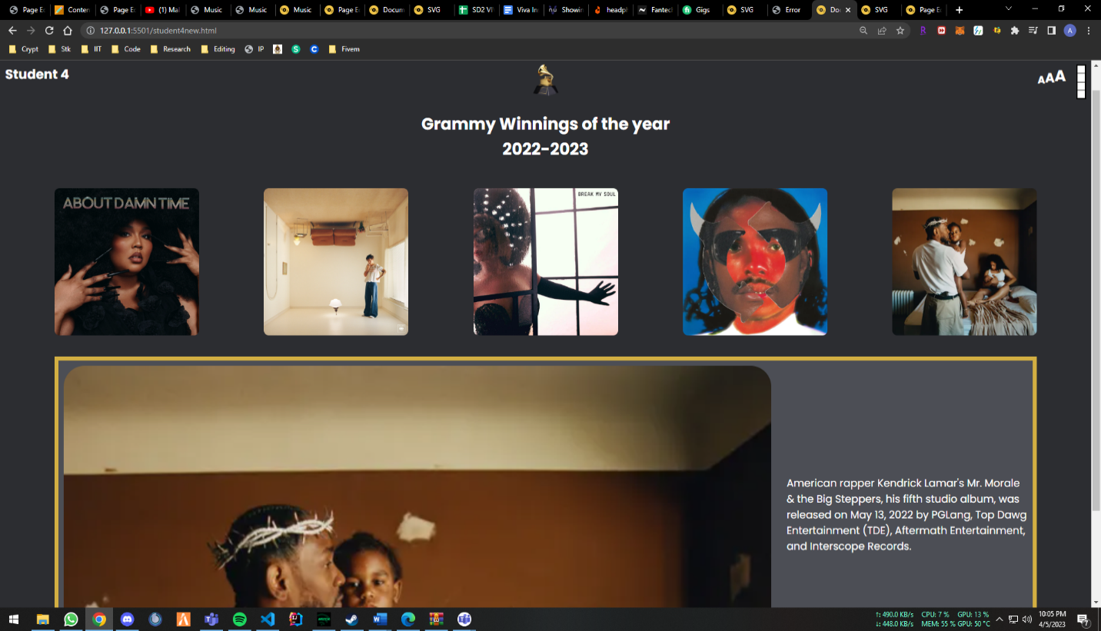

As the above output has shown I have created the page with the thumbnail images and when hovered over the images the image is enlarged and the description is shown next to it. And when hovered over the small image it shows the significance of the album. Also the font size of all the letters in the page and the page theme can be changed and a random color could also be picked.

## Code:

## HTML:

<div class="controls">

            <div class="font-size">

                <h3 class="fontsizechange" onclick="changeFont('small')">A</h3>

                <h2 class="fontsizechange" onclick="changeFont('medium')">A</h2>

                <h1 class="fontsizechange" onclick="changeFont('large')">A</h1>

            </div>

            <div class="color-theme-selector">

                <div class="color-theme" onclick="changeTheme('blue')"></div>

                <div class="color-theme" onclick="changeTheme('purple')"></div>

                <div class="color-theme" onclick="changeTheme('green')"></div>

                <div class="color-theme" onclick="changeThemeRandom()"></div>

            </div>

        </div>

Created the interface using the HTML code for the user to interact with. For changing the font size I’ve made the icons to increase and decrease the size of the fonts header tags. For the theme changing interface I have div classes.

           <div class="container" id="albumArt1">

                <img src="assets/img/albumart1.webp" alt="random img" class="image">

                <div class="overlay">

                    <div class="text">"Record of the year"</div>

                </div>

            </div>

I have created image containers as above.

## CSS:

:root{

    --background-color: rgb(44, 45, 49);

    --card-color: rgb(76, 78, 85);

}

[data-theme="purple"]{

    --background-color: purple;

    --card-color: rgb(171, 0, 171);

}

[data-theme="green"]{

    --background-color: green;

    --card-color: rgb(0, 169, 0);

}

Different theme styles pre-defined when the user clicks on changing the page theme. To change colors of the page.

### JAVASCRIPT:

const fontsSizes = {

    small: "45%",

    medium: "60%",

    large: "75%"

}

function changeFont(size){

    document.querySelector('*').style.fontSize = fontsSizes[size]

 }

The function created to change the font size of the text in the page. There are 3 predefined sizes which are implemented when the user interacts with the page and changes the font size of the webpage.

albumArt1.addEventListener("mouseover",function(){

    albumInfoPic.src = albums.album1.image

    albumDesc.innerText = albums.album1.desc

})

The function which changes the hovered image and the description when its changed from one album to another.

const themes = ["blue","purple","green"]

function changeTheme(theme){

    document.documentElement.setAttribute("data-theme", theme)

}

The function which changes the theme of the page when the user has a selected a different theme.

# Page Editor

## Output:

## Code:

## HTML:

<header>

            <h1>Page Editor</h1>

        </header>

        <div class="studentinfo">

            <text>Name - Anuda Bogahawattage<br>Role - Student 4<br>IIT-20220530<br>UOW No - 19540542<br>The following page was edited by me</text>

        </div>

        <div class="content">

            <button class="button"><span><a id="top" class="navigation" href=#topp>Go to bottom</a> </span></button>

            <h4>Diagram SVG(Sitemap)</h4>

            <p>The sitemap was created using HTML SVG Basic shapes.<br>Used javascript to animate the different links when the mouse is hovered over them.<br>Used CSS to style and resize the SVG.</p>

This is the code that was used to display the information on the page editor page. I have used buttons to create and link anchor tags and used div classes to create different sections on the page.

## CSS:

header{

    background-color: rgb(211, 175, 66);

    display: flex;

    justify-content: center;

    border-radius: 20px;

}

Header styling I have used to center and align the content in the header.

  .button span:after {

    content: '\00bb';

    position: absolute;

    opacity: 0;

    top: 0;

    right: -20px;

    transition: 0.5s;

  }

  .button:hover span {

    padding-right: 25px;

  }

  .button:hover span:after {

    opacity: 1;

    right: 0;

  }

Button animation I have created when the mouse is hovered over it.

# Extra Content Page

## Output:

## Code:

## HTML:

<div class="header" id="top">

        <h1>Hiphop Music</h1>

      </div>

      <div>

      </div>

      <div id="navbar">

        <a href="#History">History</a>

        <a href="#Style_of_music">Style Of Music</a>

        <a href=" #Famous">Famous Composers</a>

        <a href="#Thoughts">Present Thoughts</a>

      </div>

      <div class="content">

        <div class="content-iteams" id="History">

          <img src="../Images/1.jpg" class="image" alt="image1">

          <h3>History</h3>

          <p>Lorem ipsum dolor sit amet, consectetur adipiscing elit. Fusce vitae

</p>

        </div>

HTML code which was used to display the content in the additional content page. Anchor tags were used to link the different parts of the page and have used the paragraph tags to write the content.

## CSS:

  #navbar {

    display: flex;

    justify-content: center;

    background-color: #14213d;

    box-shadow: 0 0 8px 3px black;

  }

  #navbar a {

    float: left;

    display: block;

    color: #f2f2f2;

    text-align: center;

    padding: 10px 10px;

    text-decoration: none;

    font-size: 17px;

    margin: 5px;

    text-align: center;

  }

  #navbar a:hover {

    border-radius: 18px;

    background-color: gold;

    color: black;

    transition: 0.65s all ease;

  }

  .sticky {

    position: fixed;

    top: 0;

    width: 100%;

  }

  .sticky+.content {

    padding-top: 60px;

  }

Styling which was used to create the sticky nav bar in the content page to have the effect of nav bar sticking to the top of the page when scrolling down.

# Navigation Bar (Adapted)

## Output:

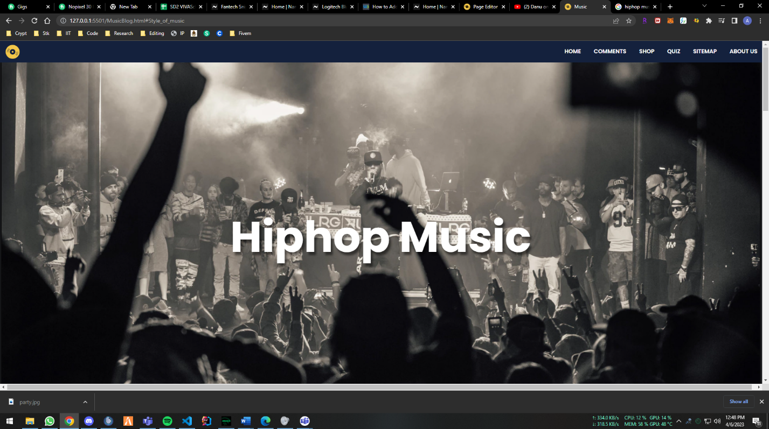

## Code:

### HTML:

<header class="navbar">

        <div class="logo">

            <img src="assets/img/cd16px.svg" class="navlogo" alt="sitelogo">

        </div>

        <div class="navbar-iteams">

          <a href="">About us</a>

          <a href="#Sitemap">Sitemap</a>

          <a href="#Quiz">Quiz</a>

          <a href="#shop">Shop</a>

          <a href="#Comments">Comments</a>

          <a href="#Home">Home</a>

        </div>

    </header>

Used div classes and anchor tags to make and categorize the nav bar.

### CSS:

.navbar{

  position: relative;

  width: 100vw;

  list-style-type: none;

  margin: 0;

  padding: 5px;

  overflow: hidden;

  top: 0;

  width: 100%;

  background-color: #14213D;

 }

 .navbar-iteams a {

  list-style: none;

  float: right;

  display: block;

  color: white;

  padding: 14px 16px;

  text-decoration: none;

  text-transform: uppercase;

  font-size: 14px;

  font-weight: 600;

  transition: 0.3 s;

  white-space: nowrap;

  line-height: 1;

 }

 .navbar .active   {

  padding: 13px 12px;

  border-radius: 18px;

  background-color: gold;

  color: black;

  transition: 0.65s all ease;

 }

 .navbar a:hover   {

  border-radius: 18px;

  background-color: gold;

  color: black;

  transition: 0.65s all ease;

 }

.logo .navlogo{

  width: 35px;

  aspect-ratio: 1/1;

  margin-bottom: 4px;

  margin-left: 10px;

  margin-top: 5px;

  float: left;

}

Used this CSS code to style the nav bar and to add a hover effect when hovered over the parts of the nav bar and styled and resized the nav bar logo the same way.

# Webpage Validation Statement

I have validated my parts of the course works using the [w3c](https://validator.w3.org/) validator to ensure that there are no errors. Under the report I have provided the necessary screenshots as proof.

# Janet

Website owners must ensure that their website complies with all applicable laws and Janet policies to ensure that it does not violate any copyright or trademark laws. The owner of a website should make sure they have the necessary licensing and permission if it allows people to submit material. So I have made sure compile with the Janet regulations mentioned.

# References

- <https://www.w3schools.com/html/html_css.asp>

- <https://www.w3schools.com/js/default.asp>

- https://www.w3schools.com/html/html5_svg.asp

# Appendices

## Appendix A: Code

* image_gallery.html

<!DOCTYPE html>

<html lang="en">

<head>

<meta charset="UTF-8">

<meta http-equiv="X-UA-Compatible" content="IE=edge">

<meta name="viewport" content="width=device-width, initial-scale=1.0">

<link rel="icon" type="image/svg" href="assets/img/cd16px.svg">

<link rel="stylesheet" href="assets/css/image_gallery.css">

<script defer src="assets/js/image_gallery.js"></script>

<title>Document</title>

</head>

<body>

<header class="navbar">

<div class="logo">

<img src="assets/img/cd16px.svg" class="navlogo" alt="sitelogo">

</div>

<div class="navbar-iteams">

<a href="#Aboutus">About us</a>

<a href="#Sitemap">Sitemap</a>

<a href="#Quiz">Quiz</a>

<a href="#shop">Shop</a>

<a href="#Comments">Comments</a>

<a href="#Home">Home</a>

</div>

</header>

<div class="header">

<h1 class="student-title">Student 4</h1>

<img src="/assets/img/grammy.png" alt="Logo">

<div class="controls">

<div class="font-size">

<h3 class="fontsizechange" onclick="changeFont('small')">A</h3>

<h2 class="fontsizechange" onclick="changeFont('medium')">A</h2>

<h1 class="fontsizechange" onclick="changeFont('large')">A</h1>

</div>

<div class="color-theme-selector">

<div class="color-theme" onclick="changeTheme('blue')"></div>

<div class="color-theme" onclick="changeTheme('purple')"></div>

<div class="color-theme" onclick="changeTheme('green')"></div>

<div class="color-theme" onclick="changeThemeRandom()"></div>

</div>

</div>

</div>

<section class="albums-section">

<div class="title">

<h2>Grammy Winnings of the year</h2>

<h2>2022-2023</h2>

</div>

<div class="albums">

<div class="container" id="albumArt1">

<img src="assets/img/albumart1.webp" alt="random img" class="image">

<div class="overlay">

<div class="text">"Record of the year"</div>

</div>

</div>

<div class="container" id="albumArt2">

<img src="assets/img/albumart2.webp" alt="random img" class="image">

<div class="overlay">

<div class="text">"Album of the year"</div>

</div>

</div>

<div class="container" id="albumArt3">

<img src="assets/img/albumart3.webp" alt="random img" class="image">

<div class="overlay">

<div class="text">"Song of the Year"</div>

</div>

</div>

<div class="container" id="albumArt4">

<img src="assets/img/albumart4.webp" alt="random img" class="image">

<div class="overlay">

<div class="text">"Best progressive R&B Album "</div>

</div>

</div>

<div class="container" id="albumArt5">

<img src="assets/img/albumart5.webp" alt="random img" class="image">

<div class="overlay">

<div class="text">"Best Dance Album"</div>

</div>

</div>

</div>

<div class="album-info">

<img src="/Images/best-rap-album-covers-7.jpg.webp" alt="" class="preview-img" id="albumInfoPic">

<div class="info-section">

<p class="albumdescription" id="albumDesc"></p>

</div>

</div>

</section>

<footer class="footer">

<div class="footer-container">

<div class="footer-row">

<div class="footer-topic">

<h3>Thank you for visiting our page</h3>

<ul>

<li><a href="#">Home</a></li>

<li><a href="#">Comments</a></li>

<li><a href="#">Shop</a></li>

<li><a href="#">Quiz</a></li>

<li><a href="#">Sitemap</a></li>

<li><a href="#">About us</a></li>

</ul>

</div>

<div class="footer-topic">

<h3>Follow Us</h3>

<div class="social-media">

<a href="#"><i class="fab fa-facebook-f"></i></a>

<a href="#"><i class="fab fa-twitter"></i></a>

<a href="#"><i class="fab fa-instagram"></i></a>

<a href="#"><i class="fab fa-linkedin-in"></i></a>

</div>

</div>

<div class="footer-topic">

<h3>Editor Information</h3>

<ul>

<li><a href="#">Page Editor</a></li>

</ul>

</div>

</div>

</div>

</footer>

</body>

</html>

* image_gallery.css

**@import** url('Main_style.css');

**:root**{

--**background-color**: **rgb**(**44**, **45**, **49**);

--card-**color**: **rgb**(**76**, **78**, **85**);

}

[data-theme="purple"]{

--**background-color**: purple;

--card-**color**: **rgb**(**171**, **0**, **171**);

}

[data-theme="green"]{

--**background-color**: green;

--card-**color**: **rgb**(**0**, **169**, **0**);

}

*{

**margin**: **0**;

**padding**: **0**;

box-sizing: **border**-box;

**font-size**: **62**.**5**%;

**font-family**: 'Poppins', **sans-serif**;

}

html,body{

**width**: **100**%;

**height**: **100**%;

**background-color**: var(--**background-color**);

}

header {

**position**: **relative**;

**background-color**: **#333**;

**color**: **#fff**;

**height**: **50px**;

**display**: flex;

**justify**-**content**: space-between;

align-items: **center**;

}

**.navMenu** {

**padding-top**: **16px**;

**position**: **absolute**;

**right**: **2**%;

}

**.header** {

**width**: **100**%;

**height**: **100px**;

**padding**: **10px**;

**display**: flex;

**justify**-**content**: space-between;

**position**: **relative**;

}

**.header** img{

**height**: **60px**;

**width**: **auto**;

**position**: **absolute**;

**left**: **50**%;

transform: translateX(**-50**%);

}

**.student-title**{

**font-size**: **2**.**5**rem;

**color**: white;

}

**.controls**{

**display**: flex;

gap: **20px**;

}

**.font-size**{

**display**: flex;

align-items: end;

**height**: fit-**content**;

}

**.font-size** h3{

**font-size**: **2**rem;

**cursor**: **pointer**;

}

**.font-size** h2{

**font-size**: **2**.**5**rem;

**cursor**: **pointer**;

}

**.font-size** h1{

**font-size**: **3**rem;

**cursor**: **pointer**;

}

**.color-theme-selector**{

**display**: flex;

**height**: fit-**content**;

**padding**: **2px**;

gap: **1px**;

flex-**direction**: column;

**background-color**: black;

}

**.color-theme**{

**width**: **15px**;

**height**: **15px**;

**background-color**: white;

}

**.albums-section**{

**display**: flex;

flex-**direction**: column;

align-items: **center**;

}

**.title**{

**display**: flex;

flex-**direction**: column;

align-items: **center**;

**margin-bottom**: **50px**;

**font-size**: **5**rem;

**color**: white;

}

**.albums**{

**display**: flex;

**justify**-**content**: space-between;

**width**: **90**%;

flex-wrap: wrap;

gap: **10px**;

}

**.album-info**{

**display**: flex;

**width**: **90**%;

**height**: **600px**;

**padding**: **10px**;

**border**: **8px** **solid** **rgb**(**211**, **175**, **66**);

**margin**: **40px** **0**;

gap:**30px**;

**background-color**: var(--card-**color**);

}

**.info-section**{

**height**: **100**%;

**width**: **25**%;

**display**: flex;

flex-**direction**: column;

**justify**-**content**: **center**;

align-items: **center**;

}

**.info-section** p{

**font-size**: **2**rem;

}

**.preview-img**{

flex: **1**;

object-fit: cover;

object-**position**: **top**;

**border**-radius: **40px**;

}

**.fontsizechange**{

**color**: white;

}

**.pagedev**{

**font-size**: **x-large**;

**margin-top**: **0px**;

**float**: **right**;

**margin-bottom**: **15px**;

**margin-right**: **15px**;

**color**: white;

}

**.button** {

**background-color**: **#4CAF50**;

**border**: **none**;

**color**: white;

**padding**: **10px** **25px**;

**text-align**: **center**;

**text-decoration**: **none**;

**display**: **inline**-**block**;

**font-size**: **16px**;

**margin**: **4px** **2px**;

**cursor**: **pointer**;

}

**.albumdescription**{

**color**: white;

}

**.container** {

**position**: **relative**;

**height**: **280px**;

aspect-ratio: **1**/**1**;

}

**.image** {

**display**: **block**;

**height**: **280px**;

aspect-ratio: **1**/**1**;

**border**-radius: **10px**;

}

**.overlay** {

**position**: **absolute**;

**top**: **0**;

**bottom**: **0**;

**left**: **0**;

**right**: **0**;

**height**: **280px**;

aspect-ratio: **1**/**1**;

**opacity**: **0**;

transition: **.5s** ease;

**background-color**: grey;

**border**-radius: **10px**;

}

**.container:hover** **.overlay** {

**opacity**: **0**.**88**;

}

**.text** {

**color**: gold;

**font-size**: **20px**;

**position**: **relative**;

**top**: **50**%;

**left**: **50**%;

-webkit-transform: translate(**-50**%, **-50**%);

-ms-transform: translate(**-50**%, **-50**%);

transform: translate(**-50**%, **-50**%);

**text-align**: **center**;

}

* image_gallery.js

**const** albumArt1 = document.getElementById("albumArt1")

**const** albumArt2 = document.getElementById("albumArt2")

**const** albumArt3 = document.getElementById("albumArt3")

**const** albumArt4 = document.getElementById("albumArt4")

**const** albumArt5 = document.getElementById("albumArt5")

**function** getRandomInt(max) {

**return** Math.floor(Math.random() * max);

}

**const** albumInfoPic = document.getElementById("albumInfoPic")

**const** albumDesc = document.getElementById("albumDesc")

**const** albums = {

album1:{

image: "/assets/img/albumart1.webp",

desc: "The lead track from Lizzo's fourth studio album Special, About Damn Time, was made available on April 14, 2022, by Nice Life Recordings and Atlantic Records. (2022). The song peaked at number one in the US, where it became her second number-one single."

},

album2:{

image: "assets/img/albumart2.webp",

desc: "Harry Styles' third studio album, Harry's Home, was released on May 20, 2022, by Columbia Records and Erskine. Harry Styles is an English singer and songwriter. The album, which has been hailed as Styles' most contemplative work, was mostly written and recorded between 2020 and 2021."

},

album3:{

image: "assets/img/albumart3.webp",

desc: "Beyoncé, an American singer and songwriter, has a single out called Break My Soul. As the first single from Beyoncé's seventh studio album, Renaissance, it was made available on June 20, 2022, through Parkwood Entertainment and Columbia Records (2022). "

},

album4:{

image: "assets/img/albumart4.webp",

desc: "The second studio album by American musician Steve Lacy is titled Gemini Rights. RCA Records published it on July 15, 2022. It comes after Lacy's 2019 self-titled debut album Apollo XXI, which was preceded by the tracks Mercury, Bad Habit, and Sunshine. "

},

album5:{

image: "assets/img/albumart5.webp",

desc: "American rapper Kendrick Lamar's Mr. Morale & the Big Steppers, his fifth studio album, was released on May 13, 2022 by PGLang, Top Dawg Entertainment (TDE), Aftermath Entertainment, and Interscope Records."

},

}

**const** fontsSizes = {

small: "45%",

medium: "60%",

large: "75%"

}

**function** changeFont(size){

document.querySelector('*').style.fontSize = fontsSizes[size]

}

albumArt1.addEventListener("mouseover",**function**(){

albumInfoPic.src = albums.album1.image

albumDesc.innerText = albums.album1.desc

})

albumArt2.addEventListener("mouseover",**function**(){

albumInfoPic.src = albums.album2.image

albumDesc.innerText = albums.album2.desc

})

albumArt3.addEventListener("mouseover",**function**(){

albumInfoPic.src = albums.album3.image

albumDesc.innerText = albums.album3.desc

})

albumArt4.addEventListener("mouseover",**function**(){

albumInfoPic.src = albums.album4.image

albumDesc.innerText = albums.album4.desc

})

albumArt5.addEventListener("mouseover",**function**(){

albumInfoPic.src = albums.album5.image

albumDesc.innerText = albums.album5.desc

})

**const** themes = ["blue","purple","green"]

**function** changeTheme(theme){

document.documentElement.setAttribute("data-theme", theme)

}

**function** changeThemeRandom(){

document.documentElement.setAttribute("data-theme", themes[getRandomInt(**3**)])

}

* sitemap.html

<!DOCTYPE html>

<html lang="en">

<head>

<meta charset="UTF-8">

<meta http-equiv="X-UA-Compatible" content="IE=edge">

<meta name="viewport" content="width=device-width, initial-scale=1.0">

<link rel="icon" type="image/svg" href="assets/img/cd16px.svg">

<link rel="stylesheet" href="assets/css/sitemap.css">

<script defer src="assets/js/sitemap.js"></script>

<title>SVG</title>

</head>

<body>

<header class="navbar">

<div class="logo">

<img src="assets/img/cd16px.svg" class="navlogo" alt="sitelogo">

</div>

<div class="navbar-iteams">

<a href="">About us</a>

<a href="#Sitemap">Sitemap</a>

<a href="#Quiz">Quiz</a>

<a href="#shop">Shop</a>

<a href="#Comments">Comments</a>

<a href="#Home">Home</a>

</div>

</header>

<div class="title">

<h1>Sitemap</h1>

</div>

<div class="svg">

<svg class="sitemap" width="1000" height="400" viewBox="0 0 1598 698" xmlns="http://www.w3.org/2000/svg">

<circle cx="792.5" cy="85.5" r="82.5" fill="#00FF00" stroke="black" stroke-width="6" />

<text x="792.5" y="85.5" font-size="33px" dominant-baseline="middle" text-anchor="middle">Home</text>

<circle id="branchCircle4" cx="793.5" cy="612.5" r="82.5" fill="#1BD615" stroke="black" stroke-width="6" />

<text id="branchText4" x="793.5" y="612.5" font-size="33px" dominant-baseline="middle" text-anchor="middle">Quiz</text>

<circle cx="1273.5" cy="612.5" r="82.5" fill="#1BD615" stroke="lightgrey" stroke-width="6" />

<text class="sitemaptext" x="1273.5" y="612.5" font-size="33px" dominant-baseline="middle" text-anchor="middle" stroke="grey" fill="grey">Sitemap</text>

<circle id="branchCircle2" cx="321.5" cy="612.5" r="82.5" fill="#1BD615" stroke="black" stroke-width="6" />

<text id="branchText2" x="321.5" y="612.5" font-size="33px" dominant-baseline="middle" text-anchor="middle">

<tspan x="321.5" dy="-0.2em">Buy</tspan>

<tspan x="321.5" dy="1em">Products</tspan>

</text>

<circle id="branchCircle5" cx="1038.5" cy="612.5" r="82.5" fill="#1BD615" stroke="black" stroke-width="6" />

<text id="branchText5" x="1038.5" y="612.5" font-size="33px" dominant-baseline="middle" text-anchor="middle">

<tspan x="1038.5" dy="-0.2em">Student</tspan>

<tspan x="1038.5" dy="1em">Details</tspan>

</text>

<circle id="branchCircle1" cx="85.5" cy="612.5" r="82.5" fill="#1BD615" stroke="black" stroke-width="6" />

<text id="branchText1" x="85.5" y="612.5" font-size="33px" dominant-baseline="middle" text-anchor="middle">

<tspan x="85.5" dy="-0.2em">Content</tspan>

<tspan x="85.5" dy="1em">Page</tspan>

</text>

<circle id="branchCircle6" cx="1512.5" cy="612.5" r="82.5" fill="#1BD615" stroke="black" stroke-width="6" />

<text id="branchText6" x="1512.5" y="612.5" font-size="33px" dominant-baseline="middle" text-anchor="middle">Gallery</text>

<circle id="branchCircle3" cx="560.5" cy="612.5" r="82.5" fill="#1BD615" stroke="black" stroke-width="6" />

<text id="branchText3" x="560.5" y="612.5" font-size="33px" dominant-baseline="middle" text-anchor="middle">

<tspan x="560.5" dy="-0.2em">Query</tspan>

<tspan x="560.5" dy="1em">Form</tspan>

</text>

<line x1="83" y1="349" x2="1515" y2="349" stroke="grey" stroke-width="6" />

<line x1="86" y1="352" x2="86" y2="527" stroke="grey" stroke-width="6" />

<line x1="321" y1="352" x2="321" y2="527" stroke="grey" stroke-width="6" />

<line x1="560" y1="352" x2="560" y2="527" stroke="grey" stroke-width="6" />

<line x1="1038" y1="352" x2="1038" y2="527" stroke="grey" stroke-width="6" />

<line x1="792" y1="352" x2="792" y2="527" stroke="grey" stroke-width="6" />

<line x1="792" y1="171" x2="792" y2="346" stroke="grey" stroke-width="6" />

<line x1="1273" y1="352" x2="1273" y2="527" stroke="grey" stroke-width="6" />

<line x1="1512" y1="352" x2="1512" y2="527" stroke="grey" stroke-width="6" />

</svg>

</div>

<div>

<img src="assets/img/sitemapbackground.jpeg" alt="bg" class="bgpicture">

</div>

<footer class="footer">

<div class="footer-container">

<div class="footer-row">

<div class="footer-topic">

<h3>Thank you for visiting our page</h3>

<ul>

<li><a href="#">Home</a></li>

<li><a href="#">Comments</a></li>

<li><a href="#">Shop</a></li>

<li><a href="#">Quiz</a></li>

<li><a href="#">Sitemap</a></li>

<li><a href="#">About us</a></li>

</ul>

</div>

<div class="footer-topic">

<h3>Follow Us</h3>

<div class="social-media">

<a href="#"><i class="fab fa-facebook-f"></i></a>

<a href="#"><i class="fab fa-twitter"></i></a>

<a href="#"><i class="fab fa-instagram"></i></a>

<a href="#"><i class="fab fa-linkedin-in"></i></a>

</div>

</div>

<div class="footer-topic">

<h3>Editor Information</h3>

<ul>

<li><a href="#">Page Editor</a></li>

</ul>

</div>

</div>

</div>

</footer>

</body>

</html>

* sitemap.css

**@import** url(Main_style**.css**);

*{

**margin**: **0**;

**font-family**: 'Poppins', **sans-serif**;

}

html,body{

**width**: **100**%;

**height**: **100**%;

**background-color**: **rgb**(**44**, **45**, **49**);

}

**.sitemap**{

**width**: **100**%;

}

svg{

**margin-top**: **300px**;

**height**: **420px**;

**width**: **auto**;

**position**: **absolute**;

**left**: **50**%;

transform: translateX(**-50**%);

}

h1{

**font-size**: **xx-large**;

**color**: white;

**margin-top**: **120px**;

**position**: **absolute**;

**left**: **50**%;

transform: translateX(**-50**%);

}

**.bgpicture**{

**height**: **275px**;

**width**: **100**%;

}

**.footer**{

**margin-top**: **580px**;

}

* sitemap.js

**const** branchCircle1 = document.getElementById("branchCircle1")

**const** branchText1 = document.getElementById("branchText1")

**const** branchCircle2 = document.getElementById("branchCircle2")

**const** branchText2 = document.getElementById("branchText2")

**const** branchCircle3 = document.getElementById("branchCircle3")

**const** branchText3 = document.getElementById("branchText3")

**const** branchCircle4 = document.getElementById("branchCircle4")

**const** branchText4 = document.getElementById("branchText4")

**const** branchCircle5 = document.getElementById("branchCircle5")

**const** branchText5 = document.getElementById("branchText5")

**const** branchCircle6 = document.getElementById("branchCircle6")

**const** branchText6 = document.getElementById("branchText6")

branchCircle1.addEventListener("mouseenter", ()=>{

branchCircle1.setAttribute("stroke","red")

branchText1.setAttribute("fill","red")

})

branchCircle1.addEventListener("mouseleave", ()=>{

branchCircle1.setAttribute("stroke","black")

branchText1.setAttribute("fill","black")

})

branchText1.addEventListener("mouseenter", ()=>{

branchCircle1.setAttribute("stroke","red")

branchText1.setAttribute("fill","red")

})

branchText1.addEventListener("mouseleave", ()=>{

branchCircle1.setAttribute("stroke","black")

branchText1.setAttribute("fill","black")

})

branchCircle2.addEventListener("mouseenter", ()=>{

branchCircle2.setAttribute("stroke","red")

branchText2.setAttribute("fill","red")

})

branchCircle2.addEventListener("mouseleave", ()=>{

branchCircle2.setAttribute("stroke","black")

branchText2.setAttribute("fill","black")

})

branchText2.addEventListener("mouseenter", ()=>{

branchCircle2.setAttribute("stroke","red")

branchText2.setAttribute("fill","red")

})

branchText2.addEventListener("mouseleave", ()=>{

branchCircle2.setAttribute("stroke","black")

branchText2.setAttribute("fill","black")

})

branchCircle3.addEventListener("mouseenter", ()=>{

branchCircle3.setAttribute("stroke","red")

branchText3.setAttribute("fill","red")

})

branchCircle3.addEventListener("mouseleave", ()=>{

branchCircle3.setAttribute("stroke","black")

branchText3.setAttribute("fill","black")

})

branchText3.addEventListener("mouseenter", ()=>{

branchCircle3.setAttribute("stroke","red")

branchText3.setAttribute("fill","red")

})

branchText3.addEventListener("mouseleave", ()=>{

branchCircle3.setAttribute("stroke","black")

branchText3.setAttribute("fill","black")

})

branchCircle4.addEventListener("mouseenter", ()=>{

branchCircle4.setAttribute("stroke","red")

branchText4.setAttribute("fill","red")

})

branchCircle4.addEventListener("mouseleave", ()=>{

branchCircle4.setAttribute("stroke","black")

branchText4.setAttribute("fill","black")

})

branchText4.addEventListener("mouseenter", ()=>{

branchCircle4.setAttribute("stroke","red")

branchText4.setAttribute("fill","red")

})

branchText4.addEventListener("mouseleave", ()=>{

branchCircle4.setAttribute("stroke","black")

branchText4.setAttribute("fill","black")

})

branchCircle5.addEventListener("mouseenter", ()=>{

branchCircle5.setAttribute("stroke","red")

branchText5.setAttribute("fill","red")

})

branchCircle5.addEventListener("mouseleave", ()=>{

branchCircle5.setAttribute("stroke","black")

branchText5.setAttribute("fill","black")

})

branchText5.addEventListener("mouseenter", ()=>{

branchCircle5.setAttribute("stroke","red")

branchText5.setAttribute("fill","red")

})

branchText5.addEventListener("mouseleave", ()=>{

branchCircle5.setAttribute("stroke","black")

branchText5.setAttribute("fill","black")

})

branchCircle6.addEventListener("mouseenter", ()=>{

branchCircle6.setAttribute("stroke","red")

branchText6.setAttribute("fill","red")

})

branchCircle6.addEventListener("mouseleave", ()=>{

branchCircle6.setAttribute("stroke","black")

branchText6.setAttribute("fill","black")

})

branchText6.addEventListener("mouseenter", ()=>{

branchCircle6.setAttribute("stroke","red")

branchText6.setAttribute("fill","red")

})

branchText6.addEventListener("mouseleave", ()=>{

branchCircle6.setAttribute("stroke","black")

branchText6.setAttribute("fill","black")

})

* page_editor.html

<!DOCTYPE html>

<html lang="en">

<head>

<meta charset="UTF-8">

<meta http-equiv="X-UA-Compatible" content="IE=edge">

<meta name="viewport" content="width=device-width, initial-scale=1.0">

<title>Page Editor</title>

<link rel="stylesheet" href="/assets/css/page_editor.css">

<link rel="icon" type="image/svg" href="assets/img/cd16px.svg">

</head>

<body>

<div class="background">

<header>

<h1>Page Editor</h1>

</header>

<div class="studentinfo">

<p>Name - Anuda Bogahawattage<br>Role - Student 4<br>IIT-20220530<br>UOW No - 19540542<br>The following page was edited by me</p>

</div>

<div class="content">

<a class="navigation" href="#bottom"><div class="button"><span>Go to bottom </span></div></a>

<!-- <button class="button"><span><a id="top" class="navigation" href=#topp>Go to bottom</a> </span></button> -->

<h4>Diagram SVG(Sitemap)</h4>

<p>The sitemap was created using HTML SVG Basic shapes.<br>Used javascript to animate the different links when the mouse is hovered over them.<br>Used CSS to style and resize the SVG.</p>

<a class="navigation" href="#bottom"><div class="button"><span>Sitemap</span></div></a>

<h4>Image Gallery</h4>

<p>Used HTML img tags to import the pictures into the webpage.<br>Used CSS to align the pictures and resize them.<br>Used javascript to enable the hover effect with the description.<br>Used javascript to enable the resizing of the font and change the webpage theme.</p>

<a class="navigation" href="#bottom"><div class="button"><span>Image Gallery</span></div></a>

<h4>Navigation Bar</h4>

<p>Worked together on the styling and picking out the color themes.<br>Added animations using CSS.</p>

<a class="navigation" href="#bottom"><div class="button"><span>Navigation Bar</span></div></a>

<h4>Main Page</h4>

<p>We worked together to brainstorm the ideas in the main page.<br>Aided with alignments in the main page.<br></p>

<a class="navigation" href="#bottom"><div class="button"><span>Main Page</span></div></a>

</div>

</div>

</body>

</html>

* page_editor.css

**@import** url('Main_style.css');

*{

**font-family**: 'Poppins', **sans-serif**;

}

header{

**background-color**: **rgb**(**211**, **175**, **66**);

**display**: flex;

**justify**-**content**: **center**;

**border**-radius: **20px**;

}

**.studentinfo** {

**display**: flex;

**justify**-**content**: **center**;

**text-align**: **center**;

**color**: white;

**padding-top**: **20px**;

**padding-bottom**: **20px**;

**margin-top**: **20px**;

**margin-bottom**: **20px**;

**background-color**: **rgb**(**20**, **33**, **61**);

**border**-radius: **20px**;

}

**.content** {

**display**: flex;

flex-**direction**: column;

align-items: **center**;

**background-color**: **rgb**(**145**, **143**, **143**);

gap: **10px**;

**border**-radius: **20px**;

}

**.content** p{

**text-align**: **center**;

**width**: **50**%;

}

**.button** {

**border**-radius: **4px**;

**background-color**: **rgb**(**20**, **33**, **61**);

**border**: **none**;

**color**: gold;

**text-align**: **center**;

**font-size**: **18px**;

**padding**: **20px**;

**width**: **200px**;

transition: all **0.5s**;

**cursor**: **pointer**;

**margin**: **5px**;

}

**.button** span {

**cursor**: **pointer**;

**display**: **inline**-**block**;

**position**: **relative**;

transition: **0.5s**;

}

**.button** span**:after** {

**content**: '\00bb';

**position**: **absolute**;

**opacity**: **0**;

**top**: **0**;

**right**: **-20px**;

transition: **0.5s**;

}

**.button:hover** span {

**padding-right**: **25px**;

}

**.button:hover** span**:after** {

**opacity**: **1**;

**right**: **0**;

}

**.navigation**{

**color**: white;

}

h4{

**font-size**: **xx-large**;

}

**.background**{

/* width: 100%; */

**padding-left**: **275px**;

**padding-right**: **275px**;

}

a{

**text-decoration**: **none**;

}

## Appendix B: Screenshots

* image_gallery.html

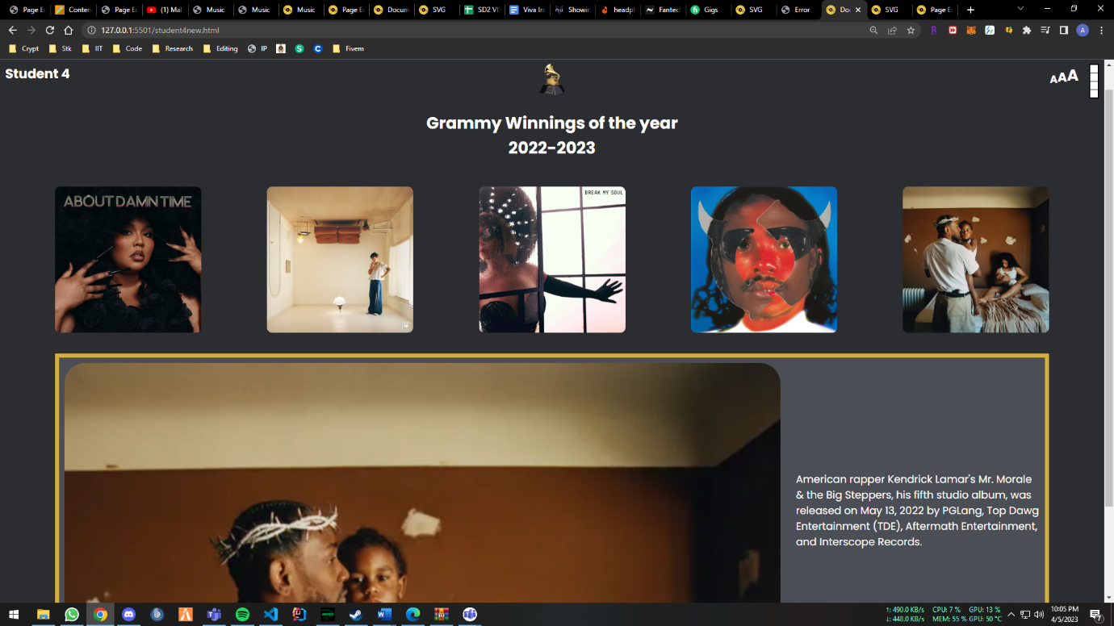

* sitemap.html

* page_editor.html

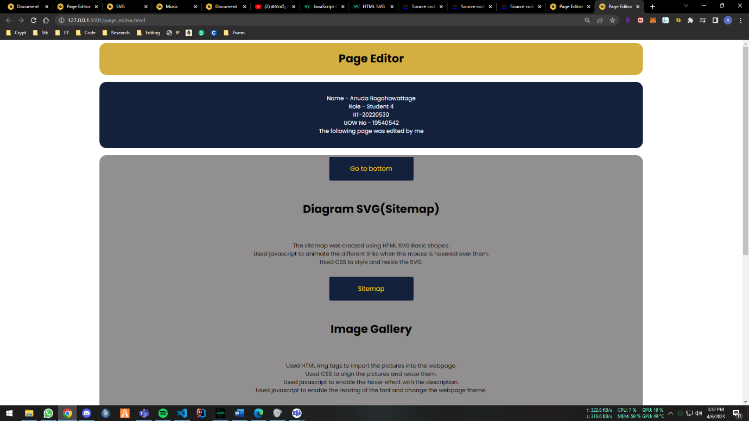

* additional_page_hiphop.html

## Appendix C: Screenshots - Webpage Validation Evidence

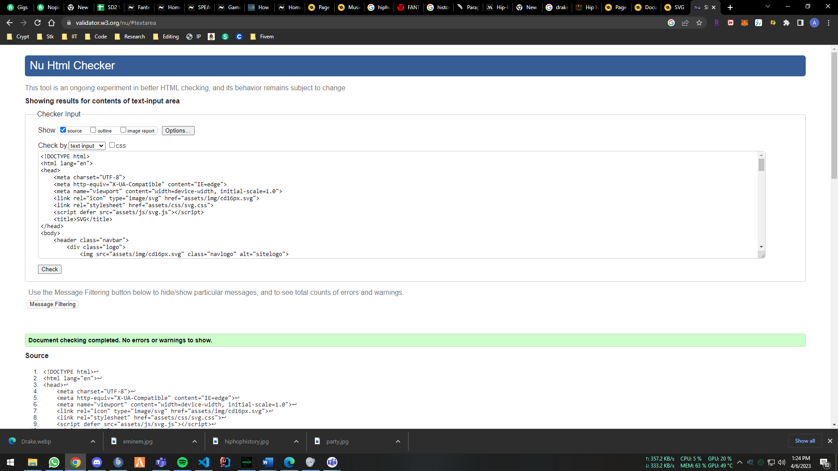

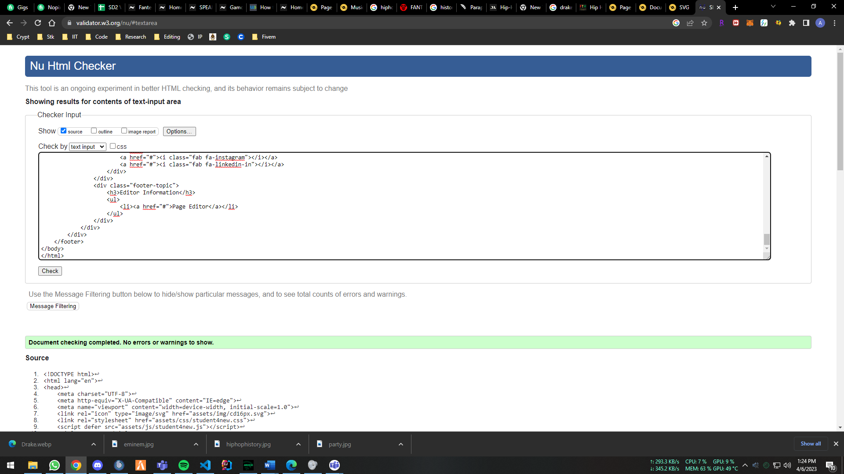

## Appendix D: Individual Statement

| Student Name: | Anuda Bogahawattage | Student Id: | 20220530 |
| --- | --- | --- | --- |
| State what tasks you carried out in the project. | | | |
| I carried out the image gallery, SVG, and page editor page in my team. | | | |
| State what you enjoyed and did not enjoy about teamwork. | | | |
| I loved doing the parts I was assigned I just didn’t like the deadline being in a such a small time. | | | |
| State what you learnt about teamwork. | | | |
| I learned how to listen to others and collaborate and finish the project. | | | |
| State what skills you gained/learnt from undertaking the project. | | | |
| I gained patience and collaborating with others from this project. | | | |
| State any strengths about yourself that emerged whilst undertaking the project. | | | |
| Working under pressure was definitely one of the main strengths that was emerged during this project. | | | |
| State any weaknesses about yourself that emerged whilst undertaking the project. | | | |
| Some times being impatient at times while doing the project. | | | |
| State how you would do things better if you were to undertake the project again. | | | |
| I would start as early as possible to not be pressured in the end. | | | |
| Additional general or project specific comments: | | | |
|  | | | |

## Appendix E: Task Completion Checklist

Complete the table to indicate if any of your tasks were not completed or partially completed.

|  |  |  |  |  |
| --- | --- | --- | --- | --- |
| **Student 1 Tasks** | **Completed** | | | **Student Comments** |
| **Yes** | **No** | **Partially** |
| 1 - Presentation Page |  |  |  |  |
| 2a - Main (Home) Page |  |  |  |  |
| 4 - Buy products |  |  |  |  |
| 9b - External CSS (9a reused) |  |  |  |  |
| 10 - Extra content page/anchors |  |  |  |  |
| 11 - Page Editor |  |  |  |  |
| 12 - Logo/Page Editor |  |  |  |  |
| 13 - Additional Interactivity |  |  |  |  |
| 14 - Uploaded to Server |  |  |  |  |

|  |  |  |  |  |
| --- | --- | --- | --- | --- |
| **Student 2 Tasks** | **Completed** | | | **Student Comments** |
| **Yes** | **No** | **Partially** |
| 2a - Main (Home) Page |  |  |  |  |
| 2b - Main site navigation |  |  |  |  |
| 3 - Query Form |  |  |  |  |
| 9b - External CSS (9a reused) |  |  |  |  |
| 10 - Extra content page/anchors |  |  |  |  |
| 11 - Page Editor |  |  |  |  |
| 12 - Logo/Page Editor |  |  |  |  |
| 13 - Additional Interactivity |  |  |  |  |
| 14 - Uploaded to Server |  |  |  |  |

|  |  |  |  |  |
| --- | --- | --- | --- | --- |
| **Student 3 Tasks** | **Completed** | | | **Student Comments** |
| **Yes** | **No** | **Partially** |
| 2a - Main (Home) Page |  |  |  |  |
| 6 – Quiz |  |  |  |  |
| 8 - Student details |  |  |  |  |
| 9b - External CSS (9a reused) |  |  |  |  |
| 10 - Extra content page/anchors |  |  |  |  |
| 11 - Page Editor |  |  |  |  |
| 12 - Logo/Page Editor |  |  |  |  |
| 13 - Additional Interactivity |  |  |  |  |
| 14 - Uploaded to Server |  |  |  |  |

| **Student 4 Tasks** | **Completed** | | | **Student Comments** |
| --- | --- | --- | --- | --- |
| **Yes** | **No** | **Partially** |
| 2a - Main (Home) Page |  |  |  |  |
| 5 - Diagram (SVG) | ✔ |  |  |  |
| 7 - Thumbnail images | ✔ |  |  |  |
| 9b - External CSS (9a reused) | ✔ |  |  |  |
| 10 - Extra content page/anchors | ✔ |  |  |  |
| 11 - Page Editor | ✔ |  |  |  |
| 12 - Logo/Page Editor | ✔ |  |  |  |
| 13 - Additional Interactivity | ✔ |  |  |  |
| 14 - Uploaded to Server | ✔ |  |  |  |